Finance HDB
Siva ram : 8977797689
Start date : 02/12/2022
EMI : 8×4776.54
Total : 56000-18666=37334+879

dell.co.in
Model : D560745WIN9B
Service tag : D6VSXR3
Express Service Code : 28714385631
Buds reg no : 311022SO833600 (31/10/2022)
Price : 1299/- ( jbl 230 NC ) within 45 days

CC ::
18004252067
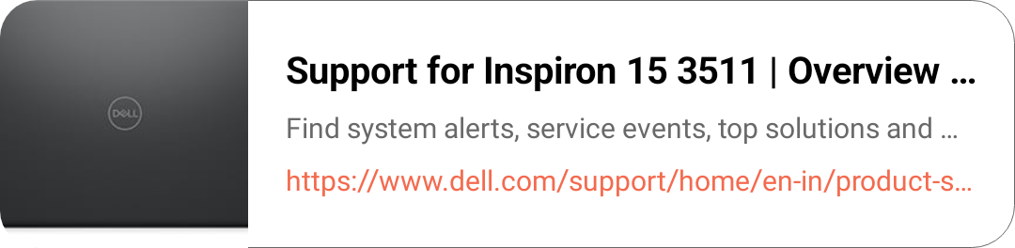

Specifications :: (24/10/2022)
4 core
I5
8gb ram (extendable upto 16gb)
512gb ssd (extendable upto 1tb *+1tb hdd)
2gb graphic card
Windows 11
11th generation
MS suit, excel, word - life time
Anti-virus - 15months

Warranty : 4249/- (02/11/2022)
Duration : 3 years (24 Oct 2025)
Coverage : accidental damage, liquid and oil spill, broken damage, etc.,

